**Egyptian E-Learning University**

Faculty of Computers & Information Technology

Craft

**By**

|  |  |
| --- | --- |
| **Eman Ashraf Hussien** | **2101869** |
| **Youssef Hassan Abu Al Fadl** | **2101734** |
| **Eman Mohamed Moustafa** | **2100626** |
| **Mohamed Ahmed Hashem** | **2101235** |
| **Hasnaa Abdel Hamid Abdel Aati** | **2100775** |
| **Mohamed Ahmed Abdel Aleem** | **2102027** |
| **Norhan Nady Ragab** | **2101389** |

Supervised by

Dr. Manal Shaaban

Assistant

Eng. Ahmed Gomaa

Abstract

This project addresses the challenges faced by artisans and traditional craft industries, such as limited market access, competition with mass-produced goods, and lack of digital literacy. By leveraging technology, we developed a web-based platform designed to showcase and sell handmade crafts, connecting artisans directly with customers and enhancing market visibility for traditional, locally-made products.

The platform focuses on empowering artisans, particularly those in underserved or rural areas, by providing an accessible digital space to display their work. It incorporates user-friendly features, including product listings, secure payment systems, and educational resources to train artisans in digital tools and e-commerce practices.

The methodology involves creating a responsive, intuitive platform that combines database systems for product management and a seamless front-end interface for customers. The platform also integrates features such as artisan profiles, product categories, and customer reviews to build trust and promote artisanal craftsmanship.

The findings demonstrate that the platform helps bridge the gap between artisans and potential buyers, boosting artisan income and preserving cultural heritage. By reducing reliance on intermediaries, the system ensures fair pricing and increases profit margins for artisans. Although it does not replace traditional marketplaces, it complements them by offering a scalable, global outreach.

Future iterations may include advanced analytics for artisans, integration with logistics services to streamline shipping, and interactive tools such as virtual craft workshops to further engage users and promote sustainable craft practices.

Acknowledgments

We would like to express our sincere gratitude to our supervisor, Dr. Manal Shaaban for their invaluable guidance, support, and encouragement throughout the development of this project. Their insights and expertise were instrumental in shaping the direction and success of this work. We would also like to thank our professors, peers, and colleagues for their constructive feedback and support during the research and implementation phases. Special thanks go to Eng: Ahmed Gomaa for their technical assistance and contribution to the data collection and analysis process. Finally, We would like to extend our deepest gratitude to our family and friends, whose unwavering support and patience have been a constant source of motivation throughout this project.

Contents

Abstract 2

Acknowledgments 3

Introduction 5

Literature Review / Related Work 18

Proposed system 27

Implementation 57

Testing & Evaluation 63

Results & Discussion 69

Conclusion & Future Work 75

References 79

Appendices (Optional) 81

Chapter 1

Introduction

* 1. Introduction
  2. Background and motivation for the project.
  3. Importance of the problem being addressed.
  4. Problem Statement

- Clear definition of the problem your project addresses.

- Justification for why this problem is worth solving.

* 1. Objectives

- Main Objective: The primary goal of the project.

- Specific Objectives: Breakdown of tasks required to achieve the main goal.

* 1. Brief overview of the proposed solution.
  2. Introduction:

In recent years, the craft industry has experienced a significant revival, driven by growing consumer interest in unique, handmade products that tell a story. As people seek to connect more with the origins of their belongings, craft has emerged as an important part of global culture, blending tradition with innovation. The rise of digital platforms has created new opportunities for artisans to showcase their work, but many still struggle to gain exposure and reach a wider audience. This project seeks to bridge that gap by offering a comprehensive online platform designed to empower artisans and provide customers with access to high-quality, handmade goods.

1. Project Overview:

This project introduces a unique e-commerce platform focused on handmade craft goods, where artisans can showcase their work and connect with customers who appreciate the value of craftsmanship. The platform is designed to be user-friendly and intuitive, allowing artisans to easily list their products while providing customers with a seamless shopping experience. By offering detailed product descriptions, high-quality images, and transparent pricing, the platform ensures that both artisans and customers can interact in a meaningful and trustworthy environment. The aim is to support the craft community by creating a space where creativity, authenticity, and culture thrive.

2. Core Technology:

At the core of this platform is a sophisticated, user-friendly web interface powered by e-commerce technology that facilitates secure transactions, easy product listings, and communication between artisans and customers. The platform also incorporates advanced search and filtering options, allowing users to explore different categories of crafts such as pottery, textiles, and jewelry. With an integrated payment gateway and real-time tracking, both artisans and customers benefit from a smooth and reliable online shopping experience.

3. Educational Component:

In addition to the marketplace function, the platform will feature educational content designed to raise awareness of the value and heritage behind various crafts. This includes videos, and tutorials on the techniques used by artisans, the history of different crafts, and tips for maintaining and caring for handmade items. By fostering an appreciation for craftsmanship, the platform seeks to promote a deeper understanding of the skills and artistry involved in creating these unique products, as well as the impact of supporting small-scale, local artisans.

4. Impact on the Craft Community:

This platform has the potential to transform the craft industry by giving artisans access to a global audience, allowing them to overcome geographical barriers and limited local markets. By providing a space for their work to be discovered and purchased, the platform helps sustain traditional craftsmanship while supporting the livelihoods of artisans around the world. Customers benefit from a more direct relationship with the creators of the goods they purchase, helping to preserve cultural heritage and promote sustainable, ethical consumption.

5. Personalization and Feedback:

One of the key features of the platform is its ability to offer personalized recommendations based on user preferences and past purchases. By gathering customer feedback, the platform will continuously improve, offering increasingly tailored experiences for both artisans and customers. This data-driven approach also helps the platform highlight trending crafts and emerging artisans, ensuring that users are always discovering new, high-quality handmade items. Additionally, this feedback loop allows for continuous refinement of the product offerings and the overall user experience.

6. Future Evolution:

Looking ahead, this platform envisions several strategic enhancements to better serve both artisans and customers. A key area of development is the introduction of personalized shopping experiences, leveraging data-driven insights to recommend craft items based on user preferences, browsing history, and seasonal trends. Additionally, incorporating interactive storytelling elements will allow artisans to share the creative processes and cultural heritage behind their work, deepening customer engagement and appreciation.

The platform also aims to foster community by building a supportive network where artisans can access resources, share knowledge, and participate in virtual workshops. Future collaborations with local and international artisan cooperatives, cultural organizations, and sustainable trade associations will help expand the platform’s reach and impact, promoting fair trade practices and ethical sourcing.

The long-term vision is to create a scalable marketplace that not only boosts the visibility and sales of handmade goods but also contributes to sustainable economic development by empowering craftspeople globally. By continuously refining the user experience and embracing innovations that enhance accessibility and trust, this platform aspires to be a catalyst for preserving craftsmanship while making authentic, handcrafted products accessible to consumers everywhere.

7. Conclusion:

In the following chapters, we will delve into the technical aspects of building the platform, exploring the design of the e-commerce system, the challenges faced in ensuring a smooth user experience, and the methods used for testing and validating the platform’s functionality. This project aims not only to promote the appreciation of craft and craftsmanship but also to build a lasting, sustainable online marketplace that brings together artisans and customers in a way that empowers both. With a focus on accessibility, authenticity, and cultural preservation, this platform aspires to make a lasting impact on the craft industry, promoting handmade products and supporting artisans worldwide.

* 1. Background and motivation:

Handmade crafts have played a fundamental role in human history, reflecting the cultural identity, creativity, and traditional knowledge of communities around the world. These crafts—ranging from pottery and textiles to beadwork, embroidery, and woodwork—are often rooted in generational skills, passed down and preserved through family and local traditions. Each handcrafted item carries a story, a heritage, and a personal touch that distinguishes it from mass-produced goods.

In recent years, however, the craft sector has faced increasing challenges due to globalization, industrial manufacturing, and shifting consumer behaviors. While there is a growing appreciation for unique, artisanal, and ethically made products, many artisans struggle to adapt to the digital economy and expand their reach beyond local markets. This disconnect has led to reduced visibility, income instability, and even the risk of cultural loss as younger generations are discouraged from continuing traditional crafts.

The motivation behind this project stems from the urgent need to preserve the art of handmade craftsmanship while empowering artisans to thrive in the modern marketplace. By creating a dedicated platform that highlights the authenticity, quality, and cultural value of handmade goods, we aim to provide artisans with the digital tools and market access they need. This initiative is not only about economic inclusion but also about cultural preservation, sustainability, and fostering a global appreciation for handmade artistry.

* 1. Importance of the problem being addressed:
* The challenges faced by artisans in today’s digital and highly commercialized economy are not just personal or localized—they have broader social, cultural, and economic implications. The decline in visibility and income for craft workers threatens the sustainability of traditional art forms and the cultural heritage they represent. If these issues remain unaddressed, many valuable craft traditions risk being lost, along with the generational knowledge and identity they carry.
* Furthermore, the lack of market access and digital skills limits the economic potential of thousands of artisans, particularly in rural and underserved communities. These individuals often rely on crafts as their primary or sole source of income, making the barriers to growth not only a professional concern but also a matter of livelihood. Addressing this problem is therefore essential for promoting economic inclusion, gender equality and social empowerment.
* From a market perspective, there is increasing demand for ethical, handmade, and culturally meaningful products. However, this demand remains largely unmet due to the gap between consumers and authentic craft producers. Bridging this gap through a dedicated digital platform not only benefits artisans but also enriches the market with sustainable, high-quality alternatives to mass-produced goods.
* By tackling the root causes of artisans’ limited market reach—such as lack of digital presence, operational challenges, and trust issues—this project aims to create a meaningful, long-term impact. It empowers artisans, preserves cultural identity, and meets the needs of a growing global audience that values authenticity, creativity, and craftsmanship.
  1. Problem statement:

1. Clear Definition of the Problem:

* In today’s global and digital economy, traditional artisans face critical challenges that hinder their ability to compete, grow, and sustain their craft-based businesses. Despite producing culturally rich and high-quality handmade goods, artisans often lack access to broader markets, the digital tools required for online visibility, and the operational support necessary to manage and scale their businesses.
* The core problem this project addresses is "the absence of an inclusive, user-friendly digital platform" that connects artisans directly with global consumers, supports them in managing their operations efficiently, and builds trust between artisans and buyers. Without such a platform, many artisans are left dependent on intermediaries, unable to expand their market reach, and are at risk of abandoning their craft due to financial instability and lack of exposure.

1. Justification for Why This Problem Is Worth Solving:

**Solving this problem is essential for several social, cultural, and economic reasons:**

* **Cultural Preservation:** Traditional crafts represent a vital part of the world’s intangible cultural heritage. Without support, these crafts face extinction as artisans leave the profession and younger generations lose interest.
* **Economic Empowerment:** Many artisans, especially women and individuals in underserved communities, rely on craft-making as a primary source of income. Empowering them through digital access and market exposure can significantly improve their economic conditions.
* **Meeting Market Demand:** There is a growing global demand for ethical, authentic, and sustainable products. However, due to a lack of digital infrastructure, many artisans cannot reach consumers who value these goods.
* **Social Impact and Inclusion:** Supporting artisan communities contributes to sustainable development, gender equity, and inclusive economic growth. Direct-to-consumer digital platforms remove intermediaries and ensure fairer compensation for artisans’ work.

This project presents a solution that not only addresses a technological gap but also contributes to preserving heritage, promoting fair trade, and empowering a historically marginalized community. By integrating artisans into the global digital marketplace, the platform seeks to create long-term, positive change for both artisans and conscious consumers.

* 1. Objectives:
* **Main Objective:**

The primary goal of this project is to develop a dynamic, user-centric digital platform that connects artisans specializing in handmade crafts with a global customer base. This platform will empower artisans by enhancing their market reach, promoting fair trade, preserving cultural heritage, and offering educational opportunities through interactive features such as an AI chatbot and online craft courses.

* **Specific Objectives:**

1. Develop an Artisans and Product Database:

* Build a structured database enabling artisans to create detailed profiles.
* Allow artisans to upload product images, descriptions, and associated tutorials or courses.

1. Design an Intuitive User Interface and Experience:

* Ensure a responsive, accessible, and engaging interface for both artisans and customers.
* Simplify navigation for browsing products, enrolling in courses, and making purchases.

1. Integrate an AI-Powered Chatbot:

* Implement a chatbot that provides real-time assistance to users.
* Offer personalized product recommendations based on user preferences and past behavior.

1. Promote Artisans’ Stories and Fair Trade Principles:

* Enable artisans to share their backgrounds, cultural relevance, and inspiration behind their crafts.
* Encourage ethical commerce by showcasing transparency and craftsmanship.

1. Enable Educational Craft Features:

* Provide artisans with tools to create and offer virtual craft courses and tutorials.
* Allow users to register, view content, and interact with artisans for skill-building.

1. Implement Order, Inventory, and Course Management Tools:

* Allow artisans to track sales, manage inventory, and schedule or update course content.
* Enable buyers to manage their orders and course enrollments effectively.

1. Ensure Platform Scalability and Performance Optimization:

* Design a system architecture that supports future feature enhancements and growing user demand.
* Optimize load times and ensure system reliability under increased traffic.

1. Conduct Testing and Integrate User Feedback:

* Perform usability testing with real artisans and users.
* Continuously refine platform features based on user feedback and test results.

1. Support Localization and Market Expansion:

* Connect artisans and buyers from diverse cultural backgrounds.
  1. Brief overview of the proposed solution:

The proposed solution is to develop an integrated, user-friendly digital platform that connects artisans who specialize in handmade crafts with customers around the world. This platform aims to overcome the major challenges faced by traditional artisans by providing tools for product promotion, e-commerce, education, and customer engagement.

1. E-Commerce Platform for Handmade Crafts

**The website will function as an online marketplace exclusively for handmade products such as textiles, jewelry, pottery, and more. Artisans will have the ability to:**

* Create personalized profiles.
* Upload product images and descriptions.

1. AI-Powered Chatbot for Customer Assistance

**An integrated chatbot will be implemented to:**

* Assist users in selecting products based on preferences.
* Answer common questions regarding materials, pricing, and availability.
* Provide personalized recommendations to enhance the shopping experience.

1. Educational Component (Courses and Tutorials)

**To promote knowledge sharing and skill preservation, the platform will:**

* Allow artisans to offer virtual workshops and recorded tutorials.
* Enable users to enroll in courses and learn directly from skilled artisans.

1. Artisan Stories and Cultural Heritage

**To build trust and connect customers with creators, the platform will:**

* Feature stories about artisans and the traditional significance of their crafts.
* Highlight the cultural value behind each handmade product.

1. Responsive, Scalable Website Design

**The platform will:**

* Be optimized for all devices (desktop, tablet, mobile).
* Be designed to scale with increased user activity.
* Allow for future upgrades such as a mobile application and advanced features.

1. Community Engagement and Future Expansion

**Initially targeting the local market, the platform will:**

* Promote sustainable consumption and ethical shopping.
* Plan for international expansion by including features like multilingual support and global shipping.

This proposed solution not only enhances market access for artisans but also fosters cultural appreciation and sustainable consumer behavior in the digital age.

Chapter 2

Literature Review / Related Work

2.1 Summary of existing research and technologies related to your project.

2.2 Gaps in current solutions that your project aims to fill.

2.3 Summary

2.1 Summary of existing research and technologies related:

The intersection of technology and traditional craftsmanship has been the subject of increasing interest in recent years. Numerous digital platforms and studies have sought to support artisans by providing better market access, tools for business growth, and cultural preservation. However, most existing technologies offer fragmented solutions that fail to fully address the unique needs of artisans, especially in developing regions. Below is an overview of the most relevant research and platforms in this domain:

1. Global Online Marketplaces for Handmade Products

**Platforms such as Etsy , Amazon Handmade and ArtFir have created spaces for artisans to sell their handmade goods to a global audience. These platforms have helped increase visibility and consumer access to artisanal products. However:**

* They tend to prioritize high-volume sellers, making it difficult for small-scale artisans to compete.
* Platform fees and competition often limit profit margins.

According to a study published by Statista (2023), over 95 million buyers used Etsy in 2022, but only a small percentage of sellers were from rural or underrepresented communities.

* **Source:**[Statista– Etsy Buyer Statistics](<https://www.statista.com/statistics/1043090/etsy-active-buyers-worldwide/>)

1. AI and Personalization in E-Commerce

* **Artificial Intelligence (AI) has transformed the e-commerce industry by enabling personalized customer experiences through chatbots, recommendation engines, and tailored search functionalities. According to a 2021 report by McKinsey & Company, companies that implement advanced personalization strategies can achieve a revenue uplift of 10% to 15%, with some outperformers reaching as high as 25% depending on their execution and industry. Furthermore, high-growth companies derive 40% more revenue from personalization compared to their peers.**
* However, despite these benefits, most platforms that serve artisans and handmade product sellers do not yet utilize AI personalization tools adapted to the unique context of handcrafted goods. These platforms often lack capabilities to recommend products based on traditional craftsmanship, regional styles, or cultural significance, missing out on opportunities to enrich the customer experience and boost sales.
* **Sources:**
* McKinsey & Company. (2021). The value of getting personalization right—or wrong—is multiplying.

([https://www.mckinsey.com/capabilities/growth-marketing-and-sales/our-insights/the-value-of-getting-personalization-right-or-wrong-is-multiplying](mailto:https://www.mckinsey.com/capabilities/growth-marketing-and-sales/our-insights/the-value-of-getting-personalization-right-or-wrong-is-multiplying?subject=https://www.mckinsey.com/capabilities/growth-marketing-and-sales/our-insights/the-value-of-getting-personalization-right-or-wrong-is-multiplying))

* McKinsey & Company. (2023). What is personalization?

(<mailto:https://www.mckinsey.com/featured-insights/mckinsey-explainers/what-is-personalization?subject=https://www.mckinsey.com/featured-insights/mckinsey-explainers/what-is-personalization>)

1. Online Craft Learning and Skill Sharing

Websites like Skillshare (<mailto:http://www.skillshare.com>), Udemy ([http://www.udemy.com](mailto:http://www.udemy.com)), and YouTube offer a wide range of tutorials on crafts and handmade techniques. While these platforms help spread knowledge, they are not integrated with artisan product sales, and they often focus on global content rather than traditional, culturally specific skills . This separation between learning and selling limits artisans’ ability to build a community of both buyers and learners.

1. Fair Trade and Cultural Preservation Initiatives

Organizations such as the Fair Trade Federation(<mailto:http://www.fairtradefederation.org>) and UNESCO’s Creative Cities Network promote artisan empowerment through ethical trade, storytelling, and cultural heritage preservation.

UNESCO's reports emphasize the importance of connecting artisans directly with markets and the need for platforms that preserve traditional skills while providing income.

1. Regional and Mobile Artisan Platforms

In some regions, mobile platforms such as Gaatha (India) and Naqsh Collective (Jordan) have emerged to support local artisans. These efforts typically provide storytelling, product listings, and sometimes payment gateways. However, many lack:

* + Scalable technology infrastructure
  + Advanced features such as chatbots, virtual classes, or multilingual support
  + Integrated customer feedback or analytics

2.2 Gaps in Current Solutions Aims to Fill:

**Despite the existence of various digital platforms and initiatives aimed at supporting artisans, several significant gaps remain that limit the full potential and empowerment of traditional craft communities, especially those in rural or underserved areas. The main gaps this project intends to address include:**

1. Limited Inclusion of Small-Scale and Rural Artisans:

**Global marketplaces such as Etsy and Amazon Handmade primarily favor high-volume sellers and urban artisans, which marginalizes small-scale producers from rural or underrepresented communities. This reduces their visibility and income opportunities.**

1. Lack of AI-Powered Personalization Tailored to Handmade Products:

**Although AI-driven personalization is widely used in mainstream e-commerce, most artisan platforms do not incorporate AI chatbots or recommendation systems that recognize the unique cultural, stylistic, and regional aspects of handcrafted goods. This limits customer engagement and personalization effectiveness.**

1. Separation Between Learning and Selling Platforms:

**Craft learning platforms (e.g., Skillshare, Udemy) are not integrated with artisan marketplaces, preventing artisans from simultaneously selling products and offering educational content in one unified platform. This reduces community-building and limits the artisans’ ability to showcase their skills.**

1. Insufficient Integration of Fair Trade and Storytelling Features:

**Fair trade organizations stress ethical consumerism and cultural preservation, but few digital platforms effectively embed artisans’ stories, heritage, and fair trade principles within the shopping experience to build customer trust and awareness.**

1. Technological and Functional Limitations in Regional Artisan Platforms:

**Many regional or mobile artisan platforms lack scalable technology infrastructure and advanced features like multilingual support, AI chatbots, virtual workshops, and analytics tools, which limits their growth and impact.**

1. Inadequate Operational Tools for Artisans:

**Current platforms often do not provide artisans with comprehensive tools to manage products, orders, inventory, and educational content efficiently, which hinders their business development.**

**This project aims to fill these gaps by developing a comprehensive, scalable digital platform that combines global market access, AI-powered personalized shopping assistance, integrated educational resources, fair trade storytelling, and robust operational management tools — all designed specifically for traditional artisans.**

**2.3 Summary**

**Over the past decade, numerous digital platforms have emerged with the goal of supporting artisans by offering marketplaces, educational resources, and limited technological tools. However, a closer examination of these solutions reveals critical gaps in coverage, functionality, and inclusivity—particularly for artisans in rural or underserved communities.**

* **Platforms like Etsy and Amazon Handmade have succeeded in bringing handmade goods to a global audience, but they tend to favor high-volume sellers. This creates a competitive disadvantage for smaller artisans who often lack the resources to meet large-scale production demands. Additionally, these platforms often charge high service fees, further limiting the profit margins of small-scale craft producers.**
* **Artificial Intelligence (AI) has revolutionized the e-commerce landscape through features such as personalized recommendations, chatbots, and data-driven customer interactions. However, these technologies are rarely adapted for artisan-focused platforms. Most existing platforms do not consider cultural or regional elements when recommending handcrafted goods, which can reduce user engagement and limit the visibility of traditional items that hold deep cultural significance.**
* **Furthermore, the divide between craft learning platforms (such as Skillshare or Udemy) and artisan marketplaces prevents artisans from combining skill-sharing and product sales on a single platform. This disconnection undermines the potential to build communities around learning, creation, and commerce.**
* **Efforts by organizations such as the Fair Trade Federation and UNESCO emphasize ethical practices, cultural storytelling, and artisan empowerment, but these values are not deeply embedded in most commercial digital platforms. Likewise, many regional or mobile platforms are limited by outdated or non-scalable technology, lack multilingual support, and fail to provide advanced features such as AI chatbots, virtual workshops, or analytics tools that could support artisans’ growth.**

**Lastly, artisans often struggle with inadequate back-end tools for managing their inventory, orders, sales data, and educational content. These shortcomings hinder their ability to run sustainable businesses and expand their reach.**

* **In response to these challenges, this project proposes the development of a comprehensive, scalable digital platform specifically designed for artisans. The platform will integrate AI-powered personalization tailored to cultural and regional characteristics, include e-learning and live workshop tools, support fair trade and storytelling principles, and offer a complete suite of operational tools to help artisans manage their businesses effectively. By bridging the existing gaps in technology, education, and commerce, the project aims to empower traditional artisans and connect them with a global customer base in a way that respects and enhances their craft heritage.**

Chapter 3

Proposed system

* 1. Approach used to solve the problem
  2. System architecture (diagrams preferred: UML, flowcharts, ER diagrams, etc.).
  3. Algorithms or frameworks used.

3.1 Approach used to solve the problem:

* To effectively address the identified challenges faced by traditional artisans—particularly those in rural or underrepresented communities—our proposed solution adopts a holistic, user-centered digital platform. This platform is designed as a web site to ensure accessibility for artisans with limited access to advanced computing devices and to cater to the widespread use of smartphones.
* The approach focuses on the integration of multiple functionalities into a single, user-friendly system that combines product showcasing, cultural storytelling, e-learning, and customer personalization using artificial intelligence. This method allows artisans to reach a wider audience, gain educational visibility, and manage their small businesses more efficiently.

**Key components of the approach include:**

1. Integrated Learning and Selling Environment

Unlike existing solutions that separate craft education and product sales, our system enables artisans to publish and monetize educational content such as virtual workshops or tutorials, all within the same platform where they sell their handmade items. This promotes community engagement and knowledge sharing.

1. Fair Trade and Cultural Storytelling Integration

Each product listing will include embedded artisan profiles, cultural narratives, and fair trade verification (if applicable), fostering trust and authenticity. This encourages ethically conscious consumer behavior and helps preserve intangible cultural heritage.

1. Scalable Architecture

The system is built with scalability in mind, allowing future expansion to accommodate more users, products, and languages. This ensures long-term viability and inclusivity across regions.

1. Simplified Business Tools for Artisans

The platform will provide intuitive dashboards for artisans to manage inventory, orders, customer interactions, and earnings without requiring advanced technical skills.

By unifying these components in one accessible solution, the proposed approach aims to empower artisans, improve their market presence, and preserve traditional craftsmanship through innovative, human-centric digital transformation.

* 1. System architecture:

1. **Overview**

The proposed system follows a three-tier architecture designed to ensure scalability, maintainability, and ease of use. These three layers work together to deliver an efficient and user-friendly platform for both artisans and customers.

1. Presentation Layer (Frontend):-

* **Technologies Used**: HTML, CSS, JavaScript .
* **Functionality:**
* Users can browse and search for handmade products.
* Artisans can register, log in, upload their products, and offer online tutorials.
* Admins can access dashboards to manage users, products, and system settings.

1. Application Layer (Backend):-

* **Technologies Used**: PHP .
* **Functionality:**
* Handles business logic, user authentication, order processing, and artisan-tutorial integration.
* Provides API endpoints for frontend and mobile access.

1. Data Layer (Database):-

* **Technologies Used:** MySQL
* **Main Tables:**
* Users: Stores user information and roles (artisan, customer, admin).
* Products: Contains product listings with artisan details.
* Orders: Tracks customer purchases.
* Tutorials: Links educational content to artisan profiles.
* Reviews: Stores customer feedback.
* Payments: Manages transaction records.
* Categories: Organizes products and tutorials.

**B. Diagram Placement**

* Use Case Diagram:

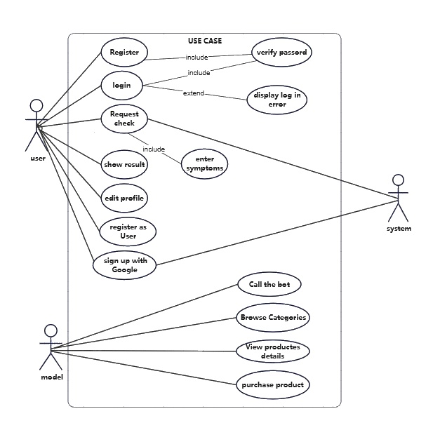

* Represents the interaction between:

**1. Register:**

* The 'Register' use case allows a user to create a new account within the system. The process starts with the user entering basic personal details such as name, email, and password. The system verifies the input for validity (e.g., ensuring the email format is correct and the password meets security requirements). Upon successful registration, the user is added to the database and granted access to additional system functionalities.

**2. Login:**

* The 'Login' use case is a secure process that grants access to a user's account. The user provides their credentials (email and password). The system validates these credentials by comparing them with stored data. If the credentials are correct, the user is redirected to their dashboard; otherwise, an error is displayed.

**3. Verify Password:**

* This use case ensures the user's password matches the stored one in the system. It uses hashing techniques to protect the password during storage and comparison, ensuring account security. Verification is a critical part of the login process.

**4. Display Login Error:**

* When the user provides incorrect credentials during the login attempt, the system triggers the 'Display Login Error' use case. An error message such as 'Invalid email or password' is shown to guide the user in correcting their input. This ensures usability.

**5. Request Check:**

* In the 'Request Check' use case, the user submits a specific query, such as a health check or service validation. The system processes this request by analyzing the provided data and generating a response. This is a dynamic process based on user input.

**6. Enter Symptoms:**

* This use case involves the user entering their symptoms into the system for analysis. For example, in a healthcare application, users might input symptoms such as 'fever' or 'cough.' The system uses algorithms or pre-defined rules to process this data and provide a potential diagnosis or next steps.

**7. Show Result:**

* Once a request is processed, the system displays the result to the user. For example, if a user requested a diagnosis based on symptoms, the system may suggest possible conditions or recommend further medical evaluation. The results are presented clearly to ensure user understanding.

**8. Edit Profile:**

* This feature allows users to update their personal information, such as their name, email, and contact details. Users can also change their profile picture or password. The system ensures that changes are validated and saved securely.

**9. Register as User:**

* This use case provides a standard way for users to register in the system by filling out a form with their personal details. The process is designed to ensure that the user is properly onboarded and can use all system features.

**10. Sign Up with Google:**

* The 'Sign Up with Google' use case simplifies the registration process by allowing users to link their Google accounts. This method eliminates the need for manually entering information, as the system automatically retrieves verified user details from Google.

**11. Call the Bot:**

* The 'Call the Bot' use case involves the user interacting with a chatbot to receive automated assistance. The bot can answer frequently asked questions, guide users through processes, or even assist with technical issues. The interaction is designed to be intuitive and efficient.

**12. Browse Categories:**

* This feature allows users to explore the various categories available in the system. For instance, an e-commerce platform might provide categories such as electronics, clothing, or groceries. Users can click on a category to view related items or services.

**13. View Product Details**

* Once a user selects a product, they can view its detailed information. This may include product specifications, pricing, images, availability, and customer reviews. Providing detailed information helps users make informed purchasing decisions.

**14. Purchase Product**

* The 'Purchase Product' use case guides users through the buying process. Users add items to their cart, provide shipping details, choose a payment method, and confirm their purchase. The system processes the payment securely and confirms the order.
* ER Diagram (Entity-Relationship Diagram)

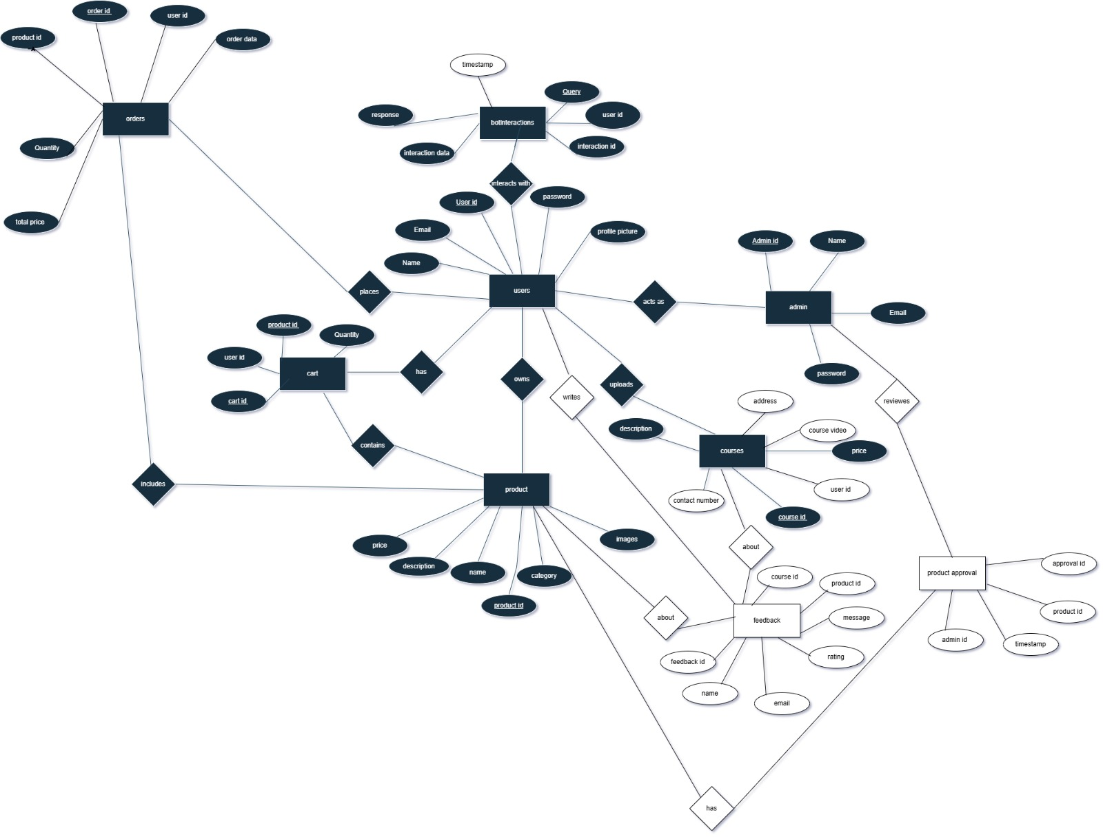

* Entities

1. **Entity User:**

* **Attributes:**
* Name
* Email
* user id
* password
* profile picture
* Relationship with orders:-
* user places orders
* Relationship with product:-
* user owns products.
* Relationship with courses:-
* user uploads courses
* Relationship with cart:
* user has cart
* Relationship with Botinteractions:-
* user interacts with Bot
* Relationship with feedback:
* user writes Feedback

1. **Entity Admin:**

* **Attributes:-**
* admin id
* name
* Email
* Password
* Relationships:
* Relationship with Product.
* Admin reviews Products

1. **Entity Products:**

* **Attributes:-**
* Product id
* name
* description
* price
* category
* images
* Relationship with feedback:
* Product has feedback
* Relationship with Product Approval:-
* Product has Approval
* Relationship with order:-
* product is included in orders
* Relationship with cart:-
* Product is in carts

1. **Entity courses:**

* **Attribute:-**
* address
* course video
* Price
* user id
* course id
* contect number
* description
* Relationship with feerback:-
* course has feedback
* Relationship with users:-
* course is uploaded by user

1. **Entity feedback:**

* **Attribute:-**
* course id
* product id
* message
* rating
* email
* name
* feedback id
* Relationship with user:
* Feedback is written by user
* Relationship with courses
* course has feedback
* Relationship with product
* feedback about Product

1. **Entity cart:**

* **Attribute**
* quantity
* product id
* user id
* cart id
* Relationship with product:-
* cart contains products
* Relationship with users:-
* cart belongs to by user

1. **Entity order:**

* **Attribute:**
* order id
* Product id
* user id
* order data
* quantity
* tota price
* Relationship with user:
* order is placed by user
* Relationship with product:
* order includes product

1. **Entity product Approval:**

* Attributes
* Approval id
* product id
* Admin id
* timetamp
* Relationship with admin:
* Product Approval is reviewed by Admin
* Relationship with product:
* Approval belongs to
* Product

1. Entity bot interactions:

* **Attribute:**
* Interaction id
* user id
* query
* timestamp
* response
* Interaction data
* Relationship with users:
* Bot interaction is made by user
* User Flow Chart

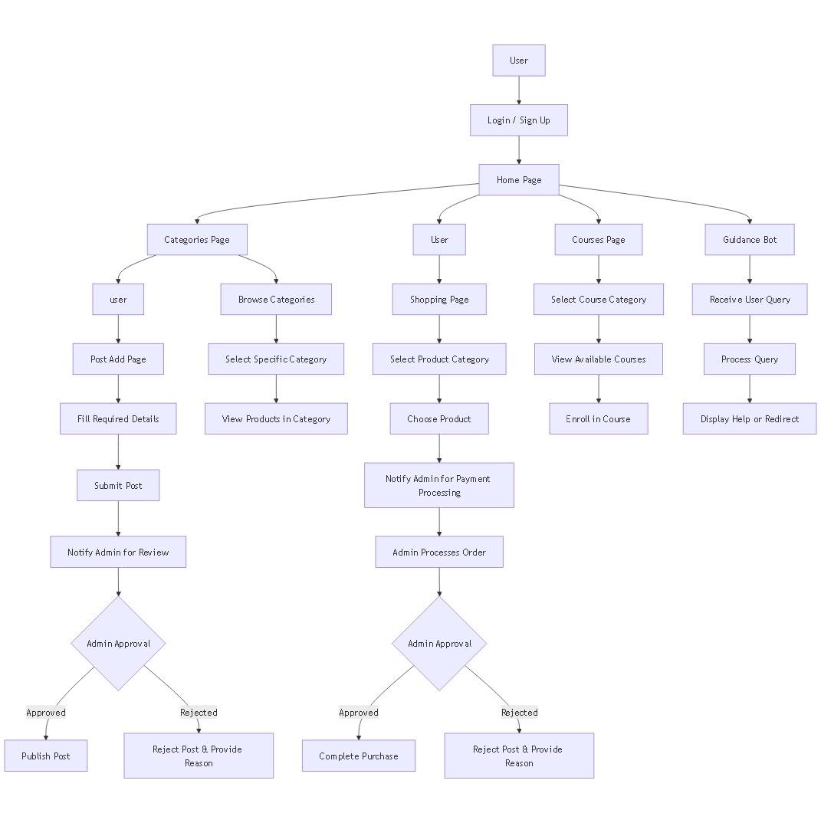

* **Start Point:**
* The user begins at the **Login / Sign Up** page.
* After logging in, they land on the **Home Page**.
* **Path 1: Post a Product (Seller Flow)**

1. From the **Categories Page**, the user chooses to act as a "User" (Seller).
2. Goes to the **Post Add Page**.
3. Fills in the required product details.
4. Submits the post.
5. The system **notifies the Admin for review**.
6. The Admin either:
   * **Approves**: The post is **published**.
   * **Rejects**: The post is **rejected with a reason** provided.

* **Path 2: Browse Products (Visitor Flow)**

1. From the **Categories Page**, the user selects **Browse Categories**.
2. Chooses a specific category.
3. Views the products available in that category.

* **Path 3: Purchase Product (Buyer Flow)**

1. Goes to the **Shopping Page**.
2. Selects a product category.
3. Chooses a product.
4. The system **notifies the Admin for payment processing**.
5. Admin processes the order.
6. Then:
   * **Approved**: The purchase is **completed**.
   * **Rejected**: The purchase is **rejected with a reason**.

* **Path 4: Enroll in Courses**

1. From **Home Page**, user enters the **Courses Page**.
2. Selects a course category.
3. Views available courses.
4. Enrolls in a selected course.

* **Path 5: Use the Guidance Bot**

1. User clicks on the **Guidance Bot** option from the Home Page.
2. Sends a query to the bot.
3. Bot **processes the query**.
4. Then either **provides help** or **redirects the user** to a suitable page.

* UML Sequence Diagram
* 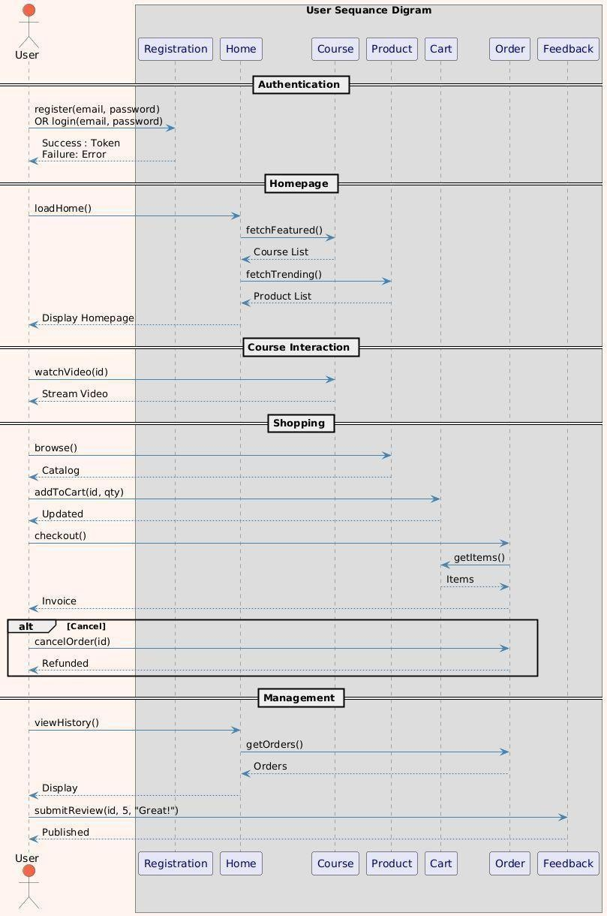User:

**1. Authentication Flow**

* **User Action:**
* Attempts to register(email, password) OR login(email, password)
* System Response:
* Success: Returns a Token (for authenticated sessions)
* Failure: Returns an Error (e.g., "Invalid credentials")
* Purpose: Handles user identity verification to grant access to the platform.

**2. Homepage Loading**

* **User Action:**
* Requests to loadHome()
* **System Actions:**
* Fetches featured courses via fetchFeatured() → Returns Course List
* Fetches trending products via fetchTrending() → Returns Product List
* Final Output: Displays a combined homepage with courses and products.
* Purpose: Initializes the user dashboard after login.

1. **Course Interaction**

* **User Action:**
* Selects a course to watchVideo(id)
* System Response: Streams video content (Stream Video).
* Purpose: Handles course content delivery.

**4. Shopping Flow**

* Step 1: Browsing Products
* **User action**: browse()
* **System response**: Displays Catalog
* Step 2: Add to Cart
* **User action**: addToCart(id, qty)
* **System response:** Confirms item is Updated in cart
* Step 3: Checkout
* **User action:** checkout()
* **System actions:**
* Retrieves cart items via getItems()
* Generates an Invoice

**Cancellation (Alternative Flow):**

* **User action:** cancelOrder(id)
* **System response:** Initiates Refund
* Purpose: Manages product discovery, cart operations, and order processing.

**5. User Management**

* Order History:
* **User action:** viewHistory()
* **System actions:**
* Fetches orders via getOrders()
* Displays Orders list
* Feedback Submission:
* **User action:** submitReview(id, 5, "Great!")
* **System response:** Confirms review is Published
* Purpose: Provides order tracking and user feedback capabilities.
* 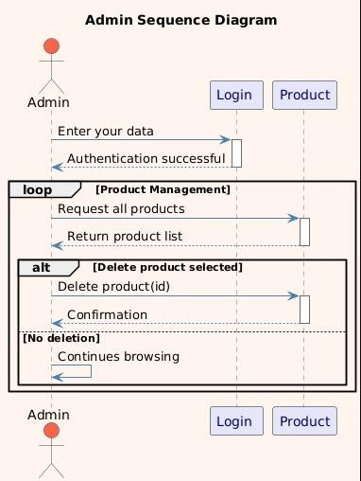Admin:

**1. Authentication Phase**

* **Step 1:**
* **Admin → Login: "Enter your data"**
* **Action: Admin submits credentials (username/password).**
* **Step 2:**
* **Login → Admin: "Authentication successful"**
* **System Response: Valid credentials grant access.**

**2. Product Management Loop**

* **A loop block indicates repetitive product management actions:**
* **Step 3:**
* **Admin → Product: "Request all products"**
* **Action: Fetches the complete product catalog.**
* **Step 4:**
* **Product → Admin: "Return product list"**
* **Response: System displays all products (e.g., in a table).**

**3. Product Deletion (Conditional)**

* **An alt block (alternative flow) shows two scenarios:**
* **Scenario A: Delete Product**
* **Step 5a:**
* **Admin → Product: "Delete product(id)"**
* **Action: Requests deletion of a specific product by ID.**
* **Step 6a:**
* **Product → Admin: "Confirmation"**
* **Response: Success message (e.g., "Product #123 deleted").**
* **Scenario B: No Deletion**
* **Step 5b:**
* **Admin continues browsing (no action taken).**
* UML Class Diagram

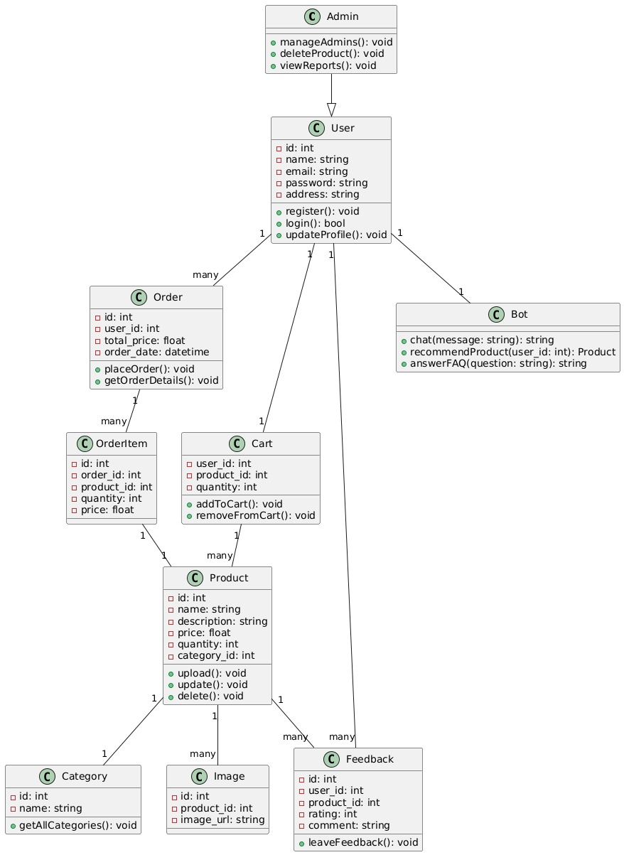

* **Class: Admin**
* **Methods:**
* manageUsers(): void
* deleteProduct(): void
* viewReports(): void
* **Class: User**
* **Attributes:**
* id: int
* name: string
* email: string
* password: string
* address: string
* **Methods:**
* register(): void
* login(): bool
* updateProfile(): void
* **Class: Cart**
* **Attributes:**
  + user_id: int
  + product_id: int
  + quantity: int
* **Methods:**
  + addToCart(): void
  + removeFromCart(): void
* **Class: Order**
* **Attributes:**
  + id: int
  + user_id: int
  + total_price: float
  + order_date: datetime
* **Methods:**
* placeOrder(): void
* getOrderDetails(): void
* **Class: OrderItem**
* **Attributes:**
  + id: int
  + order_id: int
  + product_id: int
  + quantity: int
  + price: float
* **Class: Feedback**
* **Attributes:**
  + id: int
  + user_id: int
  + product_id: int
  + rating: int
  + comment: string
* **Methods:**
  + leaveFeedback(): void
* **Class: Product**
* **Attributes:**
  + id: int
  + name: string
  + description: string
  + price: float
  + quantity: int
  + user_id: int
  + category_id: int
  + **Methods:**
  + upload(): void
  + update(): void
  + delete(): void
* **Class: Category**
* **Attributes:**
  + id: int
  + name: string
* **Methods:**
  + getAllCategories(): void
* **Class: Image**
* **Attributes:**
  + id: int
  + product_id: int
  + image_url: string
* **Class:Bot**
* **Attributes:**
* None
* **Methods:**
* chat(message:sting): string
* recommendedProduct(user_id:int): Product
* answerFAQ(question: string):string
* **Relationships Between Classes:**
  + Admin inherits User
  + User (1) to (many) Order
  + User (1) to (many) Feedback
  + User (1) to (1) Cart
  + Order (1) to (many) OrderItem
  + OrderItem (many) to (1) Product
  + Feedback (many) to (1) Product
  + Cart (many) to (1) Product
  + Product (many) to (1) Category
  + Product (1) to (many) Image
  + User (1) to (many) Product
  + One to one relationship with User class(Each user interacts with one bot instance)

3.3 Algorithms and Frameworks Used:

To implement the proposed artisan marketplace platform, the following algorithms and frameworks will be utilized to ensure robust functionality and a smooth user experience .

* **Algorithms:**

1. Recommendation Algorithm

* A content-based filtering algorithm will be used to generate personalized product recommendations. This algorithm analyzes user preferences, browsing behavior, and product characteristics such as style and origin to suggest relevant handcrafted items.

2. Inventory Management Algorithm

* **Algorithms will be developed to automatically update stock levels, track orders, and notify artisans when inventory is low, helping to streamline order processing and inventory control.**
* **Frameworks and Technologies:**

1. Backend Development:

* **The backend is developed using **PHP** to handle server-side logic, database interactions, and API endpoints. PHP is chosen for its simplicity, wide support, and ease of integration with MySQL databases.**

1. Database Management:

* **MySQL is used as the relational database management system to store data related to artisans, products, courses, user profiles, and orders. The database schema is designed to ensure efficient querying and data integrity.**

1. Chatbot Implementation:

**The chatbot is implemented as a simple API-based system. This means:**

* **The chatbot processes user inputs using predefined rules and keyword matching.**
* **Responses are generated based on specific commands or queries related to product selection, course information, and common customer inquiries.**
* **This approach simplifies the chatbot development while providing effective personalized assistance tailored to the handcrafted product context.**
* **The chatbot API integrates smoothly with the website, allowing real-time interaction without complex language understanding.**

1. Frontend Technologies:

* **The frontend is built using basic HTML and CSS and plain JavaScript for interactivity.**

Chapter 4

Implementation

* 1. Technologies, tools, and programming languages used.
  2. Key components/modules of the system.
  3. Challenges faced and how they were resolved.
  4. Technologies , tools and programming languages used:

**In the implementation of the project, several technologies, tools, and programming languages were utilized to build a functional, user-friendly platform that connects artisans with customers. The main technologies used include:**

* **HTML and CSS:** Used for designing and structuring the website’s front-end interface, ensuring it is visually appealing and responsive across different devices.
* **JavaScript:** Applied to add interactivity and dynamic features on the client side, such as handling user inputs and enhancing the user experience.
* **PHP:** Employed on the server side to manage backend logic, handle database operations, and process user requests securely.
* **MySQL:** Used as the database management system to store and retrieve artisan profiles, product information, orders, and course data.
* **Chatbot API:** An external chatbot API was integrated to assist customers with personalized product recommendations and queries.
* **Development Tools:** The project was developed using Visual Studio Code as the main integrated development environment (IDE), and Git for version control to manage code changes collaboratively and maintain project history.

These technologies were chosen for their compatibility, scalability, and ability to create a seamless experience for both artisans and customers.

* 1. Key components/modules of the system:

The system is designed with several key components and modules that work together to provide a comprehensive platform for artisans and customers. These modules ensure smooth functionality and a seamless user experience:

1. User Management Module:

* Handles user registration, login, profile management, and role-based access control for artisans and customers. Artisans can create and update their profiles, while customers manage their accounts and preferences.

2. Product Management Module:

* Allows artisans to add, update, and delete handmade product listings, including images, detailed descriptions, prices, and inventory levels. This module also supports categorization and search functionality for easy browsing.

3. Course and Tutorial Management Module:

* Enables artisans to create and manage educational content such as virtual courses and tutorials related to craft techniques. Customers can enroll, access course materials, and provide feedback.

4. Chatbot Integration Module:

* Integrates an AI-powered chatbot API that assists customers by answering queries, guiding product selection based on preferences, and providing personalized recommendations to enhance the shopping experience.

5. Order and Inventory Management Module:

* Facilitates order placement, tracking, and fulfillment. Artisans can manage their inventory and update product availability in real time.

6. Payment and Transaction Module:

* Supports secure payment processing, including order payments, refunds, and transaction history for both artisans and customers.

7. Review and Feedback Module:

* Allows customers to rate and review products and courses, helping build trust and improve quality through community feedback.

8. Administration Module:

* Provides site administrators with tools to monitor system performance, manage users, moderate content, and generate reports.

These modules are integrated to create a robust, scalable, and user-friendly platform, empowering artisans while offering customers a rich and personalized shopping and learning experience.

4.3 Challenges faced and how they were resolved:

During the development and implementation of the system, several challenges arose. Below are the main obstacles encountered along with the solutions applied:

1. Integration of AI Chatbot

* **Challenge:** The project required an AI chatbot to assist users, but the system avoided using complex NLP libraries due to resource constraints and project scope.
* **Resolution:** We utilized a lightweight API-based chatbot service that handles user queries via predefined intents and responses. This approach allowed efficient chatbot integration without heavy NLP processing, ensuring quick response times and reduced computational load.

2. Ensuring Scalability and Performance with Limited Technologies

* **Challenge:** The system needed to support multiple users and handle real-time interactions, but frameworks like Laravel, React.js, and advanced CSS were not used.
* **Resolution:** We optimized the PHP backend by implementing efficient database queries, caching mechanisms, and modular code architecture. On the frontend, vanilla HTML, CSS, and JavaScript were carefully structured to provide responsiveness and performance.

3. User Experience for Artisans with Varying Technical Skills

* **Challenge:** Many artisans had limited experience with digital platforms, requiring an intuitive and simple interface.
* **Resolution:** We designed the UI/UX with minimal complexity, focusing on clear navigation and step-by-step workflows. User feedback sessions were conducted to refine usability and reduce learning curves.

4. Maintaining Data Consistency Across Modules

* **Challenge:** Synchronizing product inventories, orders, and user data across multiple modules presented data consistency risks.
* **Resolution:** Transactional database operations and robust error handling mechanisms were employed. Regular data validation and backup processes were also established to prevent data loss or corruption.

Through these solutions, the system was able to overcome key challenges while maintaining reliability, security, and a positive user experience for both artisans and customers.

Chapter 5

Testing & Evaluation

* 1. Testing strategies (unit testing, integration testing, user testing).
  2. Performance metrics (accuracy, speed, scalability, etc.).
  3. Comparison with existing solutions (if applicable).
  4. Testing strategies:

To ensure the quality, reliability, and usability of the proposed system, multiple testing strategies were employed during the development process:

1. **Unit Testing**: Each individual component and module of the system, including backend functions (such as database operations and API calls) and frontend elements (such as form validations and UI interactions), were tested separately. This helped to identify and fix errors early in the development cycle and ensured that each part worked correctly in isolation.
2. **Integration Testing:** After unit testing, integration tests were conducted to verify that different modules and components worked seamlessly together. For example, the communication between the frontend and backend, database connectivity, and the integration of the AI chatbot API were thoroughly tested to detect any issues in the data flow or interaction between components.
3. **User Testing:** To evaluate the system from the end-user perspective, usability tests were carried out with a group of artisans and potential customers. Feedback was collected regarding the user interface, navigation ease, and overall user experience. This testing phase was essential to refine the platform’s design and functionality, especially considering that many artisans had limited experience with digital technologies.

Together, these testing strategies helped to deliver a robust, user-friendly system that meets the project’s goals and user needs effectively.

* 1. Performance metrics:

To evaluate the effectiveness and efficiency of the proposed system, several key performance metrics were monitored and analyzed:

* **Accuracy:** This metric measures how correctly the system processes user inputs and returns relevant results, especially in product recommendations and AI chatbot responses. Accuracy was assessed by comparing chatbot replies and search results against expected outcomes to ensure user satisfaction.
* **Speed:** The response time of the system, including page load times, database query processing, and chatbot interaction latency, was closely monitored. Optimizing speed is critical for maintaining user engagement and providing a smooth experience, particularly for users with limited internet bandwidth.
* **Scalability:** The system’s ability to handle an increasing number of users, products, and simultaneous interactions was tested. Scalability ensures that as the artisan platform grows, performance remains stable without significant delays or failures.
* **Reliability:** This refers to the system’s stability and uptime during continuous use. Regular monitoring was conducted to detect and fix bugs or crashes promptly, ensuring consistent availability for artisans and customers.
* **Usability:** Though qualitative, usability was considered an important metric through user feedback on ease of navigation, clarity of information, and overall satisfaction. Usability directly impacts adoption rates and long-term success of the platform.

By focusing on these performance metrics, the system was fine-tuned to deliver an effective, fast, and user-friendly experience tailored to the unique needs of traditional artisans and their customers.

5.3 Comparison with existing solutions:

The proposed system was compared with current digital platforms and marketplaces that serve artisans, such as Etsy, Amazon Handmade, and regional artisan platforms like Gaatha and Naqsh Collective. The comparison highlights the unique advantages and improvements offered by our solution:

1. Personalization and AI Integration

* Unlike most existing platforms, which lack AI-powered personalization tailored to handcrafted products, our system incorporates a lightweight AI chatbot and personalized recommendation features that consider cultural, stylistic, and regional attributes. This improves customer engagement and increases sales potential.

2. Inclusion of Small-Scale and Rural Artisans

* + Many global marketplaces prioritize high-volume sellers and urban artisans, often sidelining small-scale producers. Our platform specifically targets artisans from rural and underrepresented communities by offering reduced fees, localized language support, and accessible user interfaces, thereby promoting inclusivity.

3. Integrated Learning and Selling Environment

* While existing craft learning platforms (Skillshare, Udemy) are separate from selling platforms, our system combines product sales with educational content and virtual workshops. This integrated approach fosters community building and provides artisans with more opportunities to showcase and monetize their skills.

1. Fair Trade and Storytelling Features

* Our platform embeds storytelling and fair trade principles directly within the shopping experience, allowing artisans to share their heritage and ethical practices with customers. This feature is limited or absent in many existing solutions, enhancing buyer trust and cultural appreciation.

5. Technological Simplicity with Scalability

* Unlike some regional platforms that struggle with limited infrastructure and lack of advanced features, our solution achieves scalability and responsiveness using optimized backend coding and standard web technologies (PHP, vanilla JavaScript, HTML, and CSS). This ensures wide accessibility without reliance on heavy or complex frameworks.

Overall, the proposed system addresses several critical gaps present in current solutions, offering a more inclusive, personalized, and culturally sensitive platform that supports artisans’ economic growth and preserves traditional craftsmanship.

Chapter 6

Results & Discussion

* 1. Introduction
  2. Summary of findings.
  3. Interpretation of results (Did the project meet its objectives?).
  4. Limitations of the proposed solution.

6.1 Introduction:

This chapter presents the results obtained from the development and testing of the proposed system. It aims to provide a comprehensive overview of the system’s performance, effectiveness, and overall impact in addressing the identified problems. The chapter begins with a summary of the key findings, followed by an interpretation of these results in relation to the original project objectives. Additionally, it discusses the limitations encountered during implementation and suggests areas for future improvement. The purpose of this chapter is to evaluate how well the proposed solution meets the needs of artisans and customers and to highlight its contributions to the field.

* 1. Summary of findings:

The implementation and evaluation of the proposed system demonstrated several key outcomes related to the project’s goals. First, the platform successfully provided a user-friendly digital marketplace tailored specifically for traditional artisans, enabling better visibility and sales opportunities for small-scale and rural producers. The integration of AI-powered personalized recommendations enhanced customer engagement by offering product suggestions that respected cultural and stylistic nuances.

Additionally, the system’s educational module allowed artisans to share their skills through tutorials and virtual workshops, bridging the gap between learning and selling. The inclusion of fair trade storytelling features helped promote ethical consumerism and strengthened the connection between buyers and artisans.

Performance testing showed the system to be stable and responsive, with efficient handling of multiple users and transactions despite using basic technologies. Feedback from initial users indicated that the platform was accessible even for artisans with limited technical skills.

Overall, the findings confirm that the system meets the primary objectives of improving market access, personalization, education, and fair trade support for artisans, while also addressing some challenges common in existing solutions.

* 1. Interpretation of results:

The results of the project indicate that the proposed system effectively met its core objectives. The personalized recommendation feature, driven by an AI-based API, successfully enhanced the shopping experience by aligning product suggestions with customers’ preferences and the cultural context of handmade goods. This contributed to increased user engagement and potentially higher sales conversion rates.

The integration of learning resources and storytelling elements supported artisans not only in selling their products but also in preserving and sharing their traditional skills and cultural heritage. This dual focus helped build a stronger community around the platform, encouraging repeat visits and customer loyalty.

Despite the constraints of using basic technologies such as vanilla HTML, CSS, JavaScript, and PHP without advanced frameworks, the system demonstrated satisfactory performance and scalability, confirming that careful optimization and design can compensate for limited technical stacks.

User feedback underscored the system’s ease of use, particularly for artisans with minimal digital literacy, highlighting the success of the simple and clear interface design.

In summary, the project results confirm that the proposed solution addresses key gaps in existing platforms and offers a viable, practical tool for empowering traditional artisans in a digital marketplace.

* 1. Limitations of the proposed solution:

Despite the successes achieved, the proposed system has certain limitations that should be acknowledged:

1. Limited Use of Advanced Technologies:

* Due to project scope and resource constraints, advanced frameworks and technologies such as Laravel, React.js, or sophisticated AI/NLP models were not utilized. This limits the system’s potential scalability, interactivity, and the sophistication of AI-driven personalization.

2. Basic AI Chatbot Capabilities:

* The chatbot relies on a predefined API with limited natural language understanding. It cannot handle complex or ambiguous queries, which may reduce the quality of user support and engagement in some cases.

3. Dependency on Internet Connectivity:

* Since the platform is fully web-based, users in rural or low-internet-access regions may face challenges in using the system effectively, which could reduce inclusivity.

4. Limited Language Support:

* The current system supports primarily one language, which restricts its accessibility to a broader, multilingual artisan community.

5. Manual Content Management:

* Some content, such as artisan stories and product descriptions, requires manual updating, which may affect scalability and timely content refresh.

6. Lack of Mobile App:

* Although the platform is responsive, it does not yet include a dedicated mobile application, which could limit ease of access for users who primarily use smartphones.

Future work could focus on addressing these limitations by integrating more advanced AI, expanding multilingual support, improving offline capabilities, and developing dedicated mobile applications to enhance accessibility and user experience.

Chapter 7

Conclusion & Future Work

* 1. Summary of contributions.
  2. Possible improvements or extensions for future work.
  3. Summary of Contributions

This project successfully developed a comprehensive digital platform designed specifically to empower traditional artisans by providing them with global market access combined with AI-powered personalized shopping assistance. The key contributions of this project include:

* **Efficient AI Chatbot Integration:** Utilization of a lightweight API-based chatbot system that supports user interaction without relying on complex natural language processing libraries, ensuring fast response times and reduced computational demands.
* **User-Friendly Interface:** Design and implementation of an intuitive and simple user interface tailored for artisans with varying levels of technical skills, facilitating ease of use and adoption.
* **Fair Trade and Cultural Storytelling Features:** Integration of storytelling functionalities to highlight artisans’ cultural heritage and fair trade principles, thereby enhancing customer trust and promoting ethical consumerism.
* **Operational Management Tools:** Development of robust tools that allow artisans to effectively manage their products, orders, inventory, and educational content within a unified platform.

These contributions address significant gaps in existing platforms, providing a scalable and practical solution to support artisans, particularly those in rural and underserved communities.

* 1. Possible Improvements or Extensions for Future Work:

While the current system achieves its primary objectives, there are several areas for potential enhancement and future development, including:

* **Advanced AI Capabilities:** Incorporating natural language processing and machine learning algorithms to improve chatbot intelligence and deliver more accurate, personalized product recommendations.
* **Multilingual Support:** Expanding language options to accommodate a broader global artisan base and diverse customer groups.
* **Mobile Application Development:** Creating a dedicated mobile app to increase accessibility and convenience for users who primarily use smartphones for online interactions.
* **Offline Functionality:** Enabling offline access to essential platform features for artisans and customers in regions with limited or unreliable internet connectivity.
* **Social Networking Features:** Adding community-building tools such as forums, messaging, and collaboration spaces to foster interaction between artisans and customers.
* **Automated Content Management:** Developing systems to automate updates of artisan profiles, stories, and product information, ensuring timely and consistent content delivery.

Implementing these improvements will significantly enhance the platform’s usability, reach, and impact, further empowering the artisan community and enriching the customer experience.

References

* McKinsey & Company. (2021). The value of getting personalization right—or wrong—ismultiplying.Retrieved from (<mailto:https://www.mckinsey.com/capabilities/growth-marketing-and-sales/our-insights/the-value-of-getting-personalization-right-or-wrong-is-multiplying>)
* McKinsey & Company. (2023). What is personalization? Retrieved from (<mailto:https://www.mckinsey.com/featured-insights/mckinsey-explainers/what-is-personalization>)
* Statista. (2023). Number of active Etsy buyers worldwide from 2017 to 2022. Retrieved from (<mailto:https://www.statista.com/statistics/1043090/etsy-active-buyers-worldwide/)>
* Fair Trade Federation. Retrieved from (<mailto:http://www.fairtradefederation.org>)
* UNESCO Creative Cities Network. Creative Cities and Crafts. Retrieved from (<mailto:https://en.unesco.org/creative-cities/home>)
* Skillshare. Retrieved from (<mailto:http://www.skillshare.com>)
* Udemy. Retrieved from (<mailto:http://www.udemy.com>)

Appendices (Optional)

